Data Flow Diagram
Date | 30 September 2026
Team ID | 6ab3e8526603573ccfb3c0ff
Project Name | Auto Ticket Classification using Flow Designer
Maximum Marks | 2 Marks
Data Flow Diagram
The DFD shows how a student or teacher submits an IT helpdesk ticket, how Flow Designer classifies it using keywords, how the ticket is stored, and how the classified ticket and email notification are delivered.
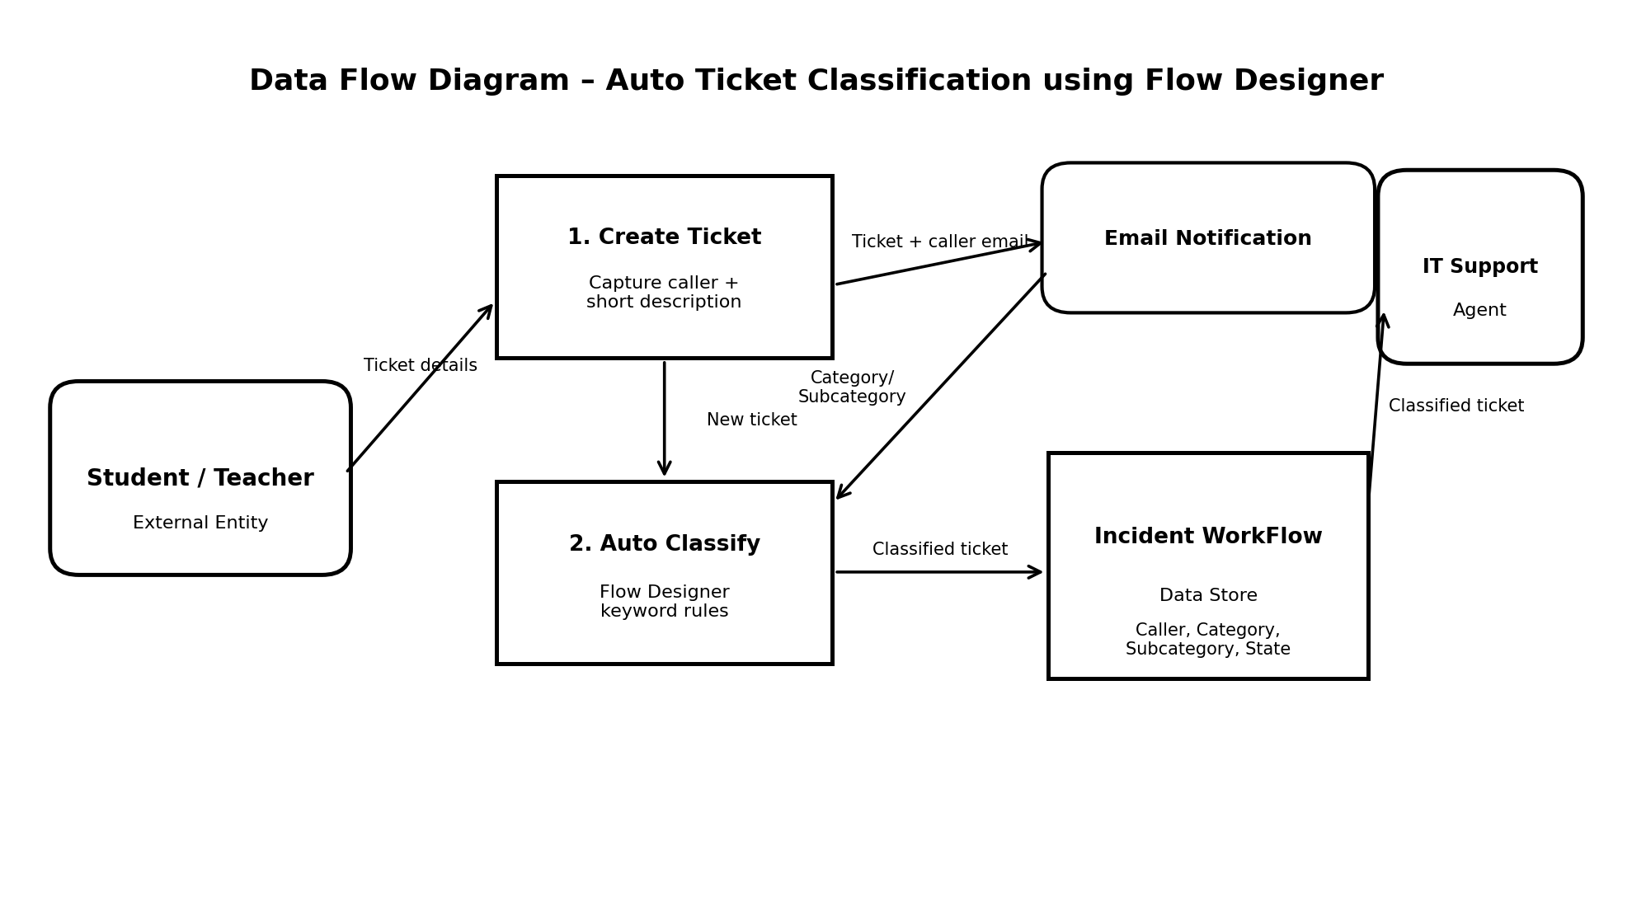
DFD Symbol Legend
Symbol | Name | Project Use
Oval / Rounded shape | External Entity | Student / Teacher and IT Support Agent
Rectangle with numbered header | Process | Create Ticket and Auto Classify
Rectangle (solid fill, no number) | Data Store | Incident WorkFlow table
Labeled arrow | Data Flow | Ticket details, classification data, and notification data

